**Project 1: visualize the Internet architecture**

Today’s Internet is arguably the largest engineered system ever created by mankind, with hundreds of millions of connected computers, communication links, and switches; with billions of users who connect via laptops, tablets, and smartphones; and with an array of new Internet-connected “things”. Given that the Internet is so large and has so many diverse components and uses, is there any hope of understanding how it works?

In this project, we will understand the Internet through the network topology. Although a complex structure consisting of heterogeneous devices (routers, switches, servers, etc.), we can represent the Internet through a graph, G (V, E). Each device is a node, V, in G. E is the edge set. An edge, e, is in the E if a link (cable, fiber, etc.) connects two devices. We can represent the Internet as an undirected or directed graph. Directed graph means node A can only communicate with node B through a physical link. However, the opposite direction does not hold. One way to analyze a graph is node degree. Node degree is the number of edges incident to a node.

In this project, you will visualize a network data set using python. The data set contains a total of 192,244 nodes, which are routers on the Internet. After you visualize it, it shows an Internet router-level graph. In the data file, each line contains two router IDs. For example,

router ID router ID

Line 1: 0 1 ←— router0 and router1 has a connection (undirected).

Line 2: 0 111 ←— router0 and router111 has a connection (undirected).

…..

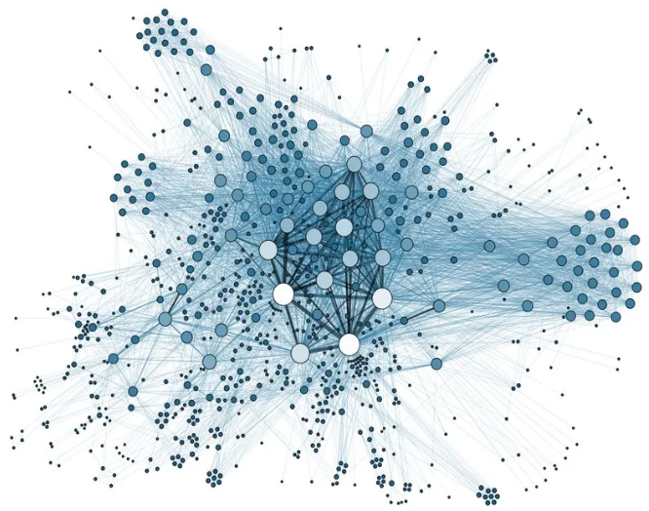 biological network graph

Your picture should have the following functions:

1. Click a node it shows corresponding node’s or device’s info (i.e. ID, # of connections, neighbors’ ID, etc.)
2. Node’s size and/or color is proportional to its degree
3. zoom in and out specific portions of the graph

What to turn in: (only one member needs to submit)

1. Your code with readme.txt (configuration instructions, installation instructions, operating instructions, contact info for authors, etc.)
2. A demo video showing how to run your code, and narrative explanation
3. A histogram showing node degree distribution as follows 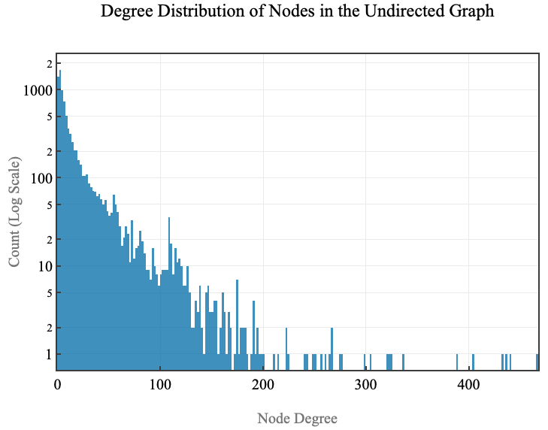
4. Due by Wednesday March 30, 2022, 11:59 pm

There are a lot of python learning materials online. Youtube is also a good place to have a look.

Python tutorial: <https://docs.python.org/3/tutorial/>

Many free cloud computing services are online. Take a look if you need one.